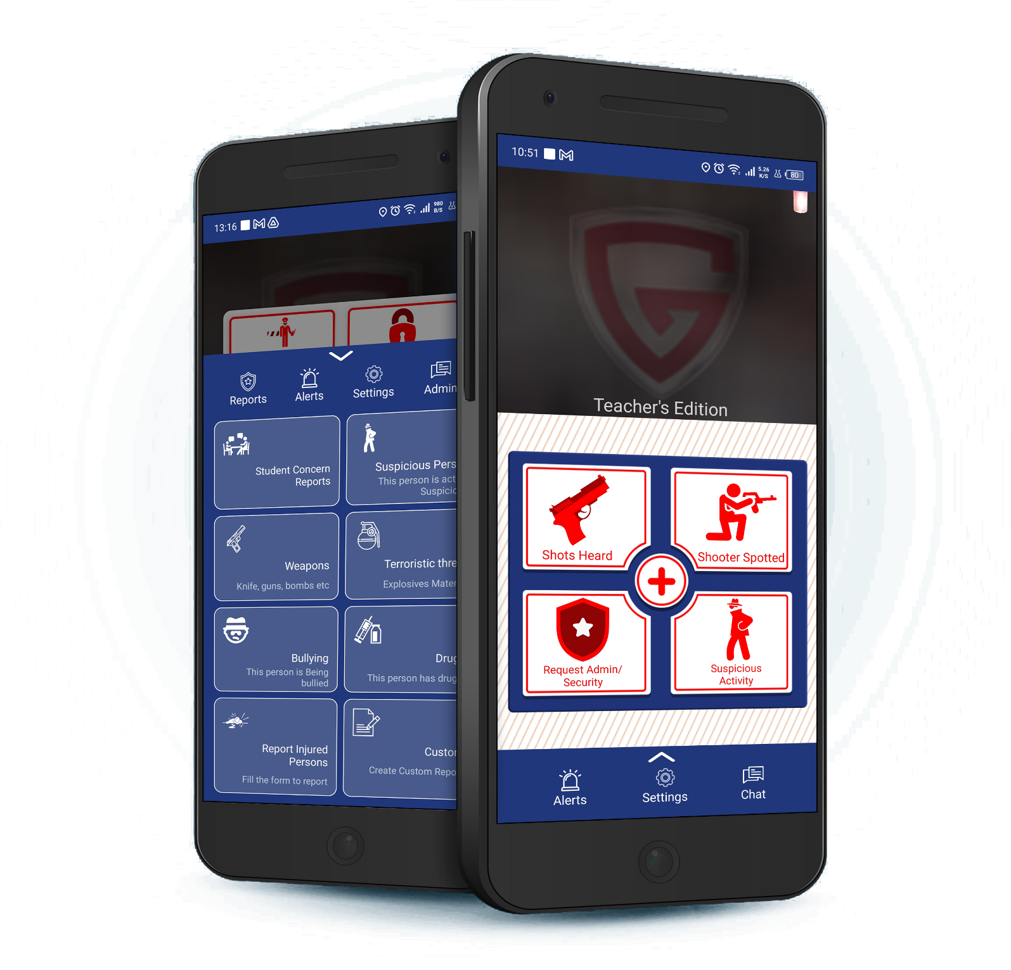
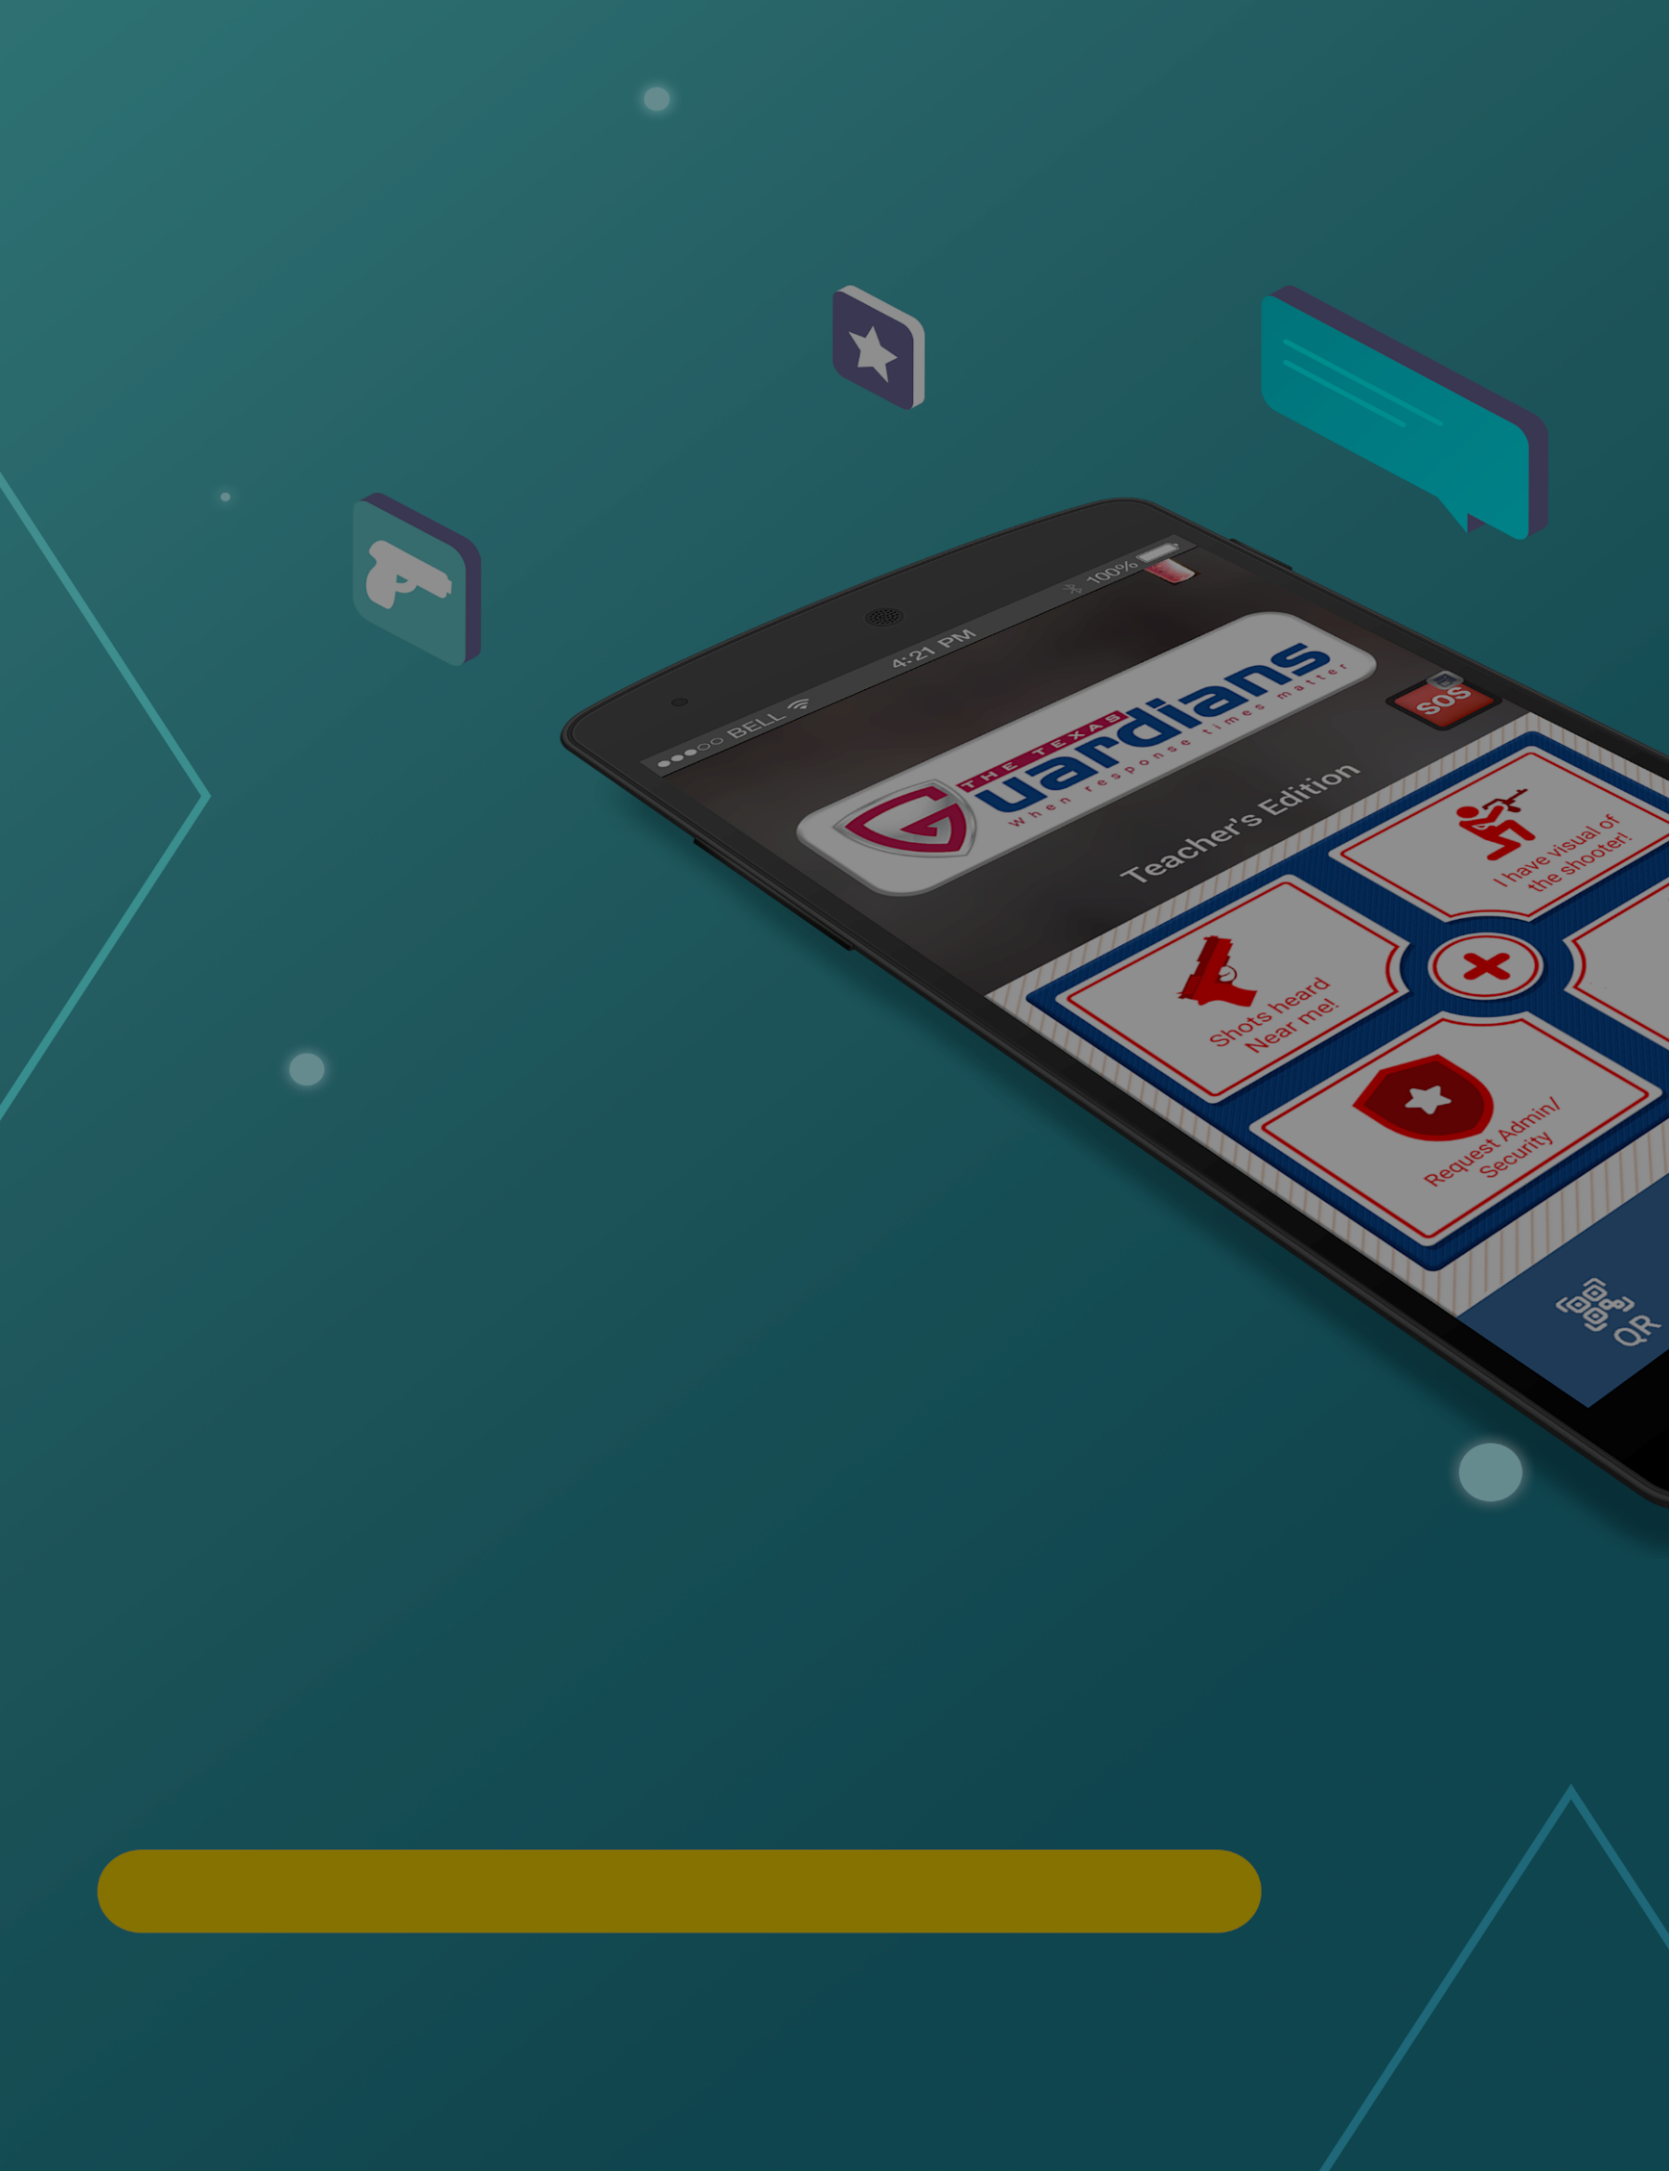
School Safety Mobile App
for Teachers & Staff Members
Information & User Manual 2023
Table of Contents
1. Getting Started 2
1.1 Supported Platforms 2
1.2 Downloading the App 2
1.3 App Permissions 3
1.4 Terms & Conditions 3
1.5 Connecting Campus 4
1.6 Selecting Your App Type 4
1.7 Create an Account 5
2. User Guidance 6
2.1 Primary Emergency Features 6
2.2 Hidden Features 6
2.3 Non-Emergency Features 7
2.4 Alerts Page 7
2.5 Chat with Admin 8
2.6 Settings Page 8

Getting Started
Teacher’s edition requires an account using an email and password. The email must be owned by you (DO NOT SHARE).
Criteria:
    - 6 – 9 characters in length
    - Avoid using first and last name
    - Must include a special character
You are responsible for your account. DO NOT SHARE your account details.

1.1 Supported Platforms
Platforms:
- Android Version 10.0+
- iPhone, iOS Version 13+

1.2 Downloading the App
Available on App Store and Play Store.
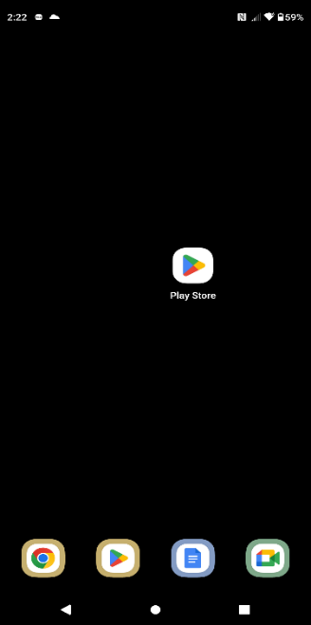
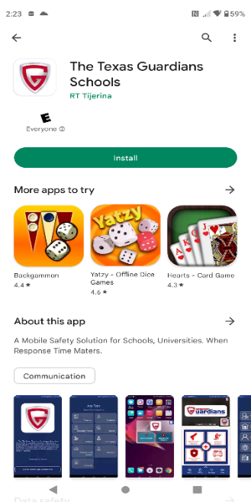
Certain features may be unavailable depending on your device.
Android Play store Download

  - Open Play Store.
  - Search “The Texas Guardians
Schools”
  - Install application.

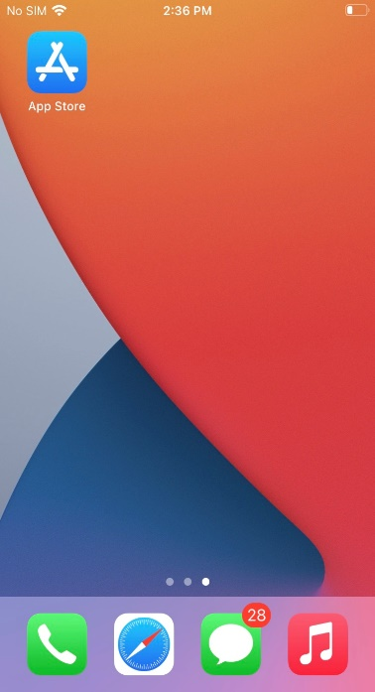
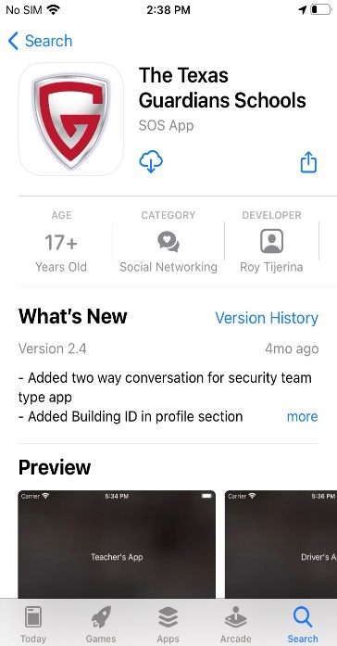

iOS Play store Download
- Open App Store
- Search “The Texas Guardians Schools”
- Install Application

1.3 App Permissions
You may be asked to accept permissions during download depending on your device. All permissions must be allowed in order for the application to function properly.

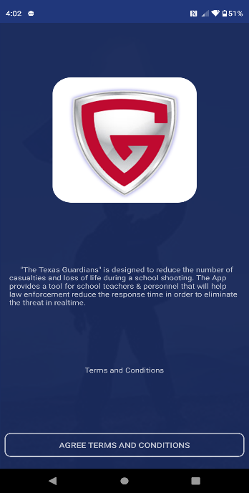
1.4 Terms & Conditions
- Read terms & conditions (Strongly Suggested).
- Tap “AGREE TERMS & CONDITIONS” button below.

1.5 Connecting Campus
- Tap on “Tap Start Searching”
- Enter your Campus Name
- Select your Campus Name from the list
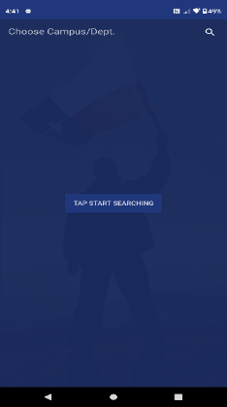
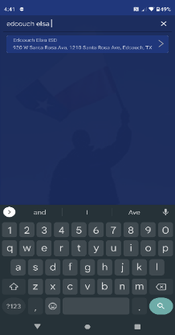
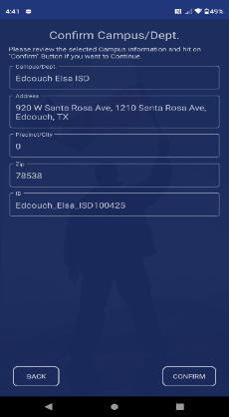
- Tap on “Confirm” on the bottom right of the screen

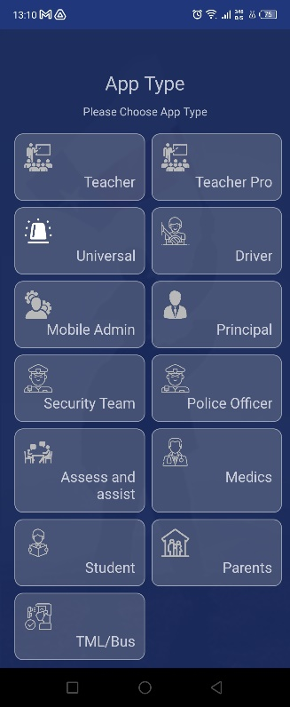
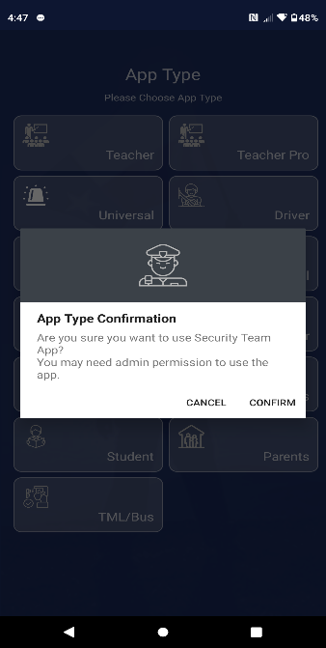

1.6 Selecting Your App Type
- Tap on the “Teacher” button.
- Select “Confirm”
- Accept all permissions

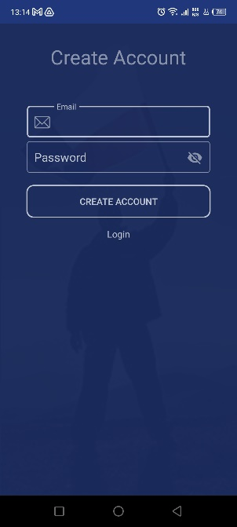

1.7 Create an Account
- Tap on “Create Account”
- Input Email and Password and tap “Create Account” button.

Upon creating your account, you must confirm your email address.
- Once verified, log in.

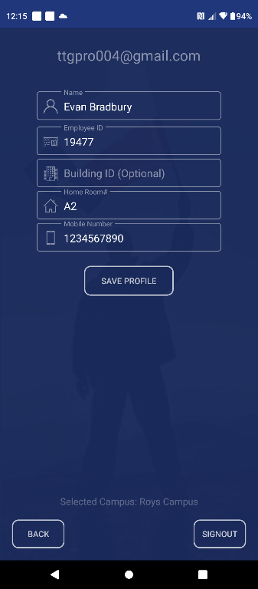
Profile Requirements:
- Full Name
- Employee ID
- Assigned Location
- Mobile Number
- Once completed, tap on “Save Profile”
This app is not functional until the admin has verified and approved your account.

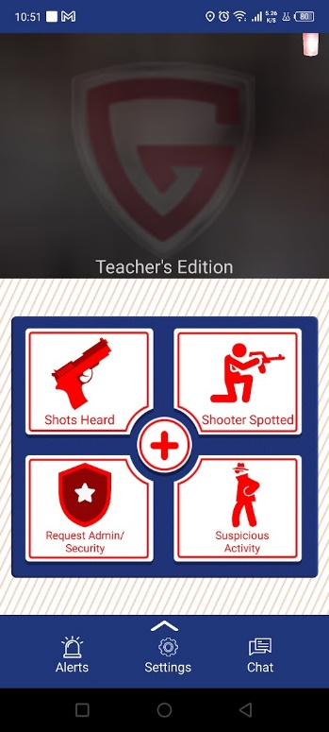
User Guidance

2.1 Primary Emergency Features
5 Primary Emergency Buttons
- Shots heard
  - Gunshot Detected.
- Shooter Spotted
  - Visual of an Active Shooter.
- Medical Assistance
  - Medical Injury
- Suspicious Activity
  - Abnormal Behavior
- Request Security/Admin
  - Request Security assistance for any situation

2.2 Hidden Features
- The app will prompt you to enter your device’s pin or pattern when a report is selected.
- Upload an optional image alongside the report. You are NOT required to upload an image.
- Auto-dial 911 upon complete submission of an emergency alert.
- Live location ONLY tracked after submission of an emergency report
- Automatically enables the device “DO NOT DISTURB” feature after submitting a report.
- Manually disable live tracking from the home screen.
- Request Admin/Security will send an alert to all security members & campus admin.

2.3 Non-Emergency Features
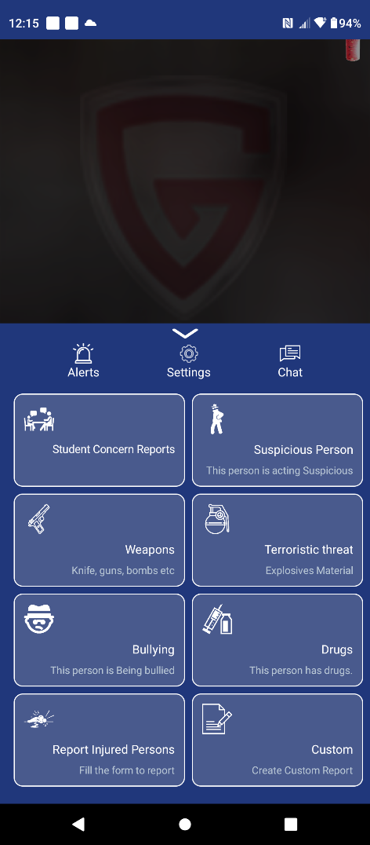
8 Non-Emergency Buttons:
- Student Concerns Reports
  - Mental or physical health concerns.
- Suspicious Person
  - Abnormal Person.
- Weapons
  - Non-Firearms.
- Terroristic Threat
Comment of a terroristic nature.
- Bullying
  - Bullied Student.
- Drugs
  - Drugs found within the campus.
- Report Injured Persons
  - Non-life-threatening medical injury.
- Custom Report
  - Submit a custom report.
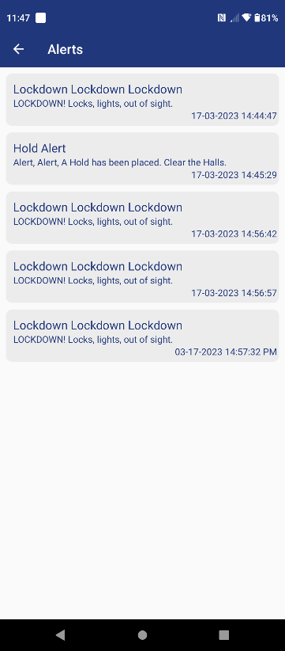

2.4 Alerts Page
- View all mass notification alerts.

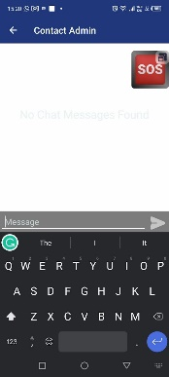

2.5 Chat with Admin
1-on-1 Private Message.

2.6 Settings Page
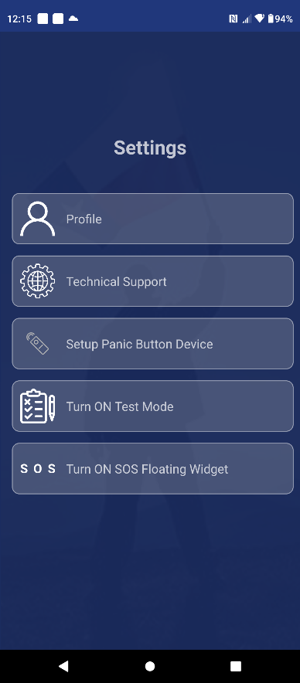
The Features on the Settings Page are as follows:

- Update your profile information
  - Full Name
  - Employee ID
  - Assigned Location
  - Mobile Number
- Technical Support
  - Online Customer support 24/7.
- Setup Panic Button Device
  - Bluetooth & WIFI setup for the TTG Panic Device.

- Test mode
  - Verify App Functionality.
- SOS Floating Widget
  - “Shots Heard” & “Request for Security” reports

