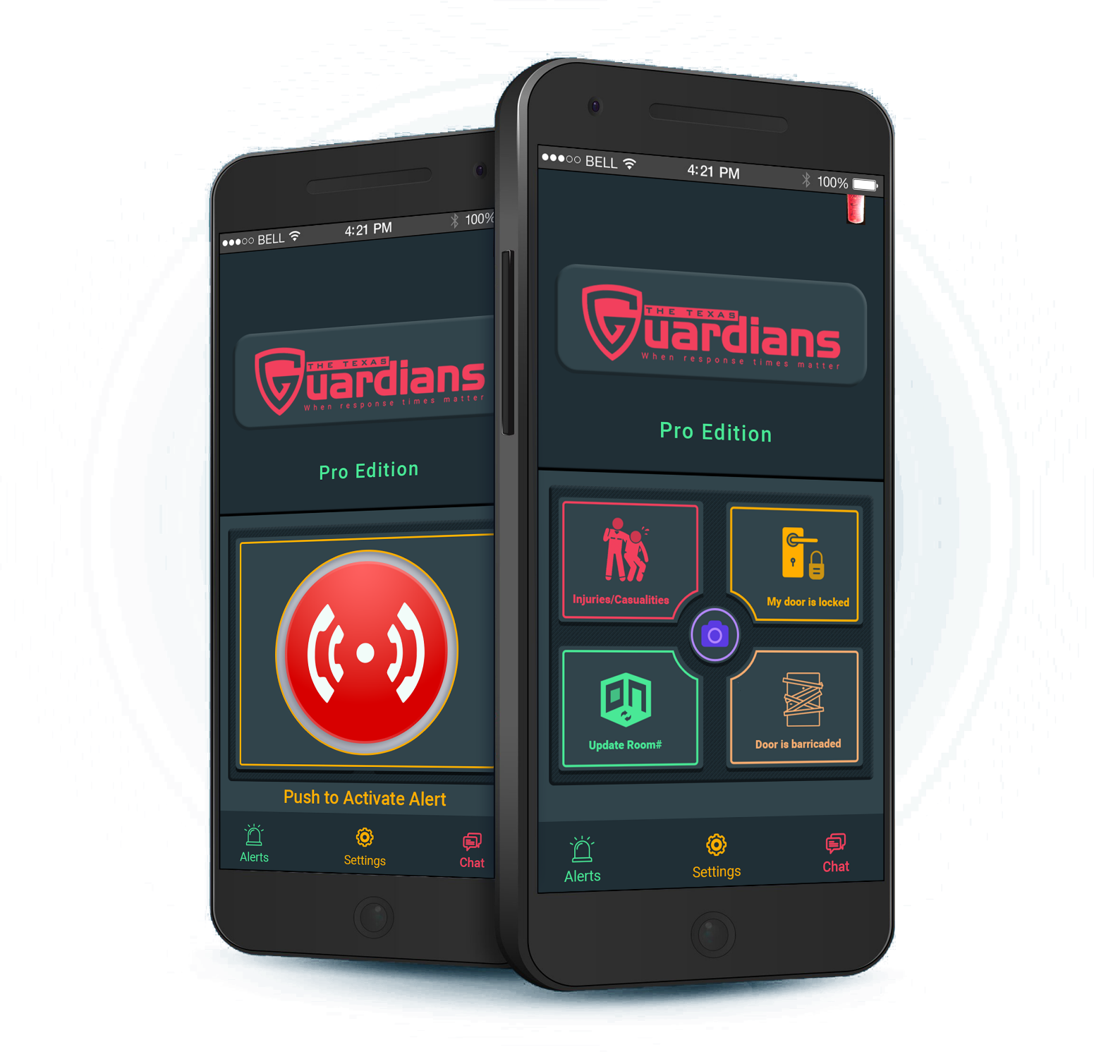
www.thetexasguardians.com | Teacher Pro Edition 2023
User Manual
Teacher Pro APP

Table of Contents
1. Getting Started 2
1.1 Supported Platforms 2
1.2 Downloading the App 2
1.3 App Permissions 3
1.4 Terms & Conditions 3
1.5 Connecting Campus 4
1.6 Selecting Your App Type 4
1.7 Create an Account 5
2. User Guidance 6
2.1 Primary Emergency Button 6
2.2 Hidden Features 6
2.3 Additional Buttons 6
2.4 Alerts Page 7
2.5 Chat with Admin 7
2.6 Settings Page 8

Getting Started
The Teacher Pro edition requires an account, prompting you to create one using an email and password. The email must be owned by you (DO NOT SHARE).
Criteria:
    - 6 – 9 characters in length
    - Avoid using first and last name
    - Must include a special character
You are responsible for your account. DO NOT SHARE your account details.

1.1 Supported Platforms
Platforms:
- Android Version 10.0+
- iPhone, iOS Version 13+

1.2 Downloading the App
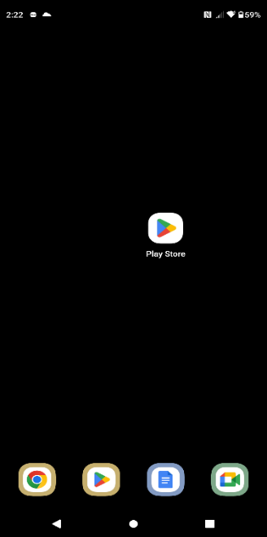
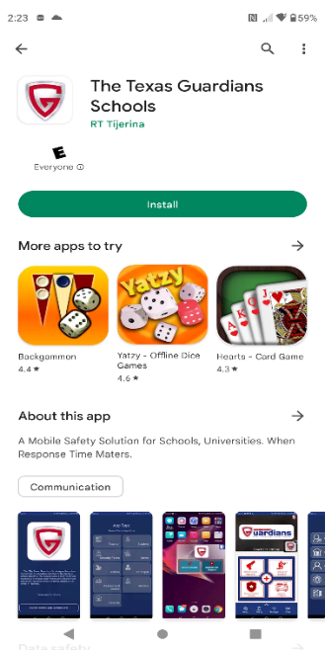
Available on the Play Store.
Android Play store Download

  - Open Play Store.
  - Search “The Texas Guardians
Schools”
  - Install application.

1.3 App Permissions
You may be asked to accept permissions during download depending on your device. All permissions must be allowed in order for the application to function properly.

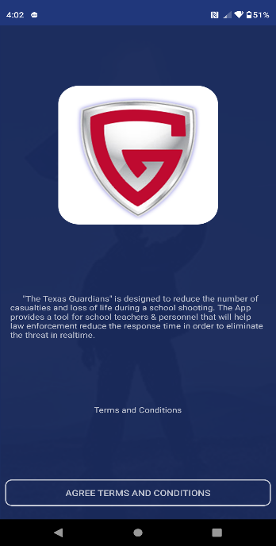
1.4 Terms & Conditions
- Read terms & conditions (Strongly Suggested).
- Tap “AGREE TERMS & CONDITIONS” button below.

1.5 Connecting Campus
- Tap on “Tap Start Searching”
- Enter your Campus Name
- Select your Campus Name from the list
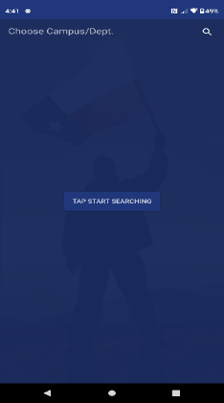
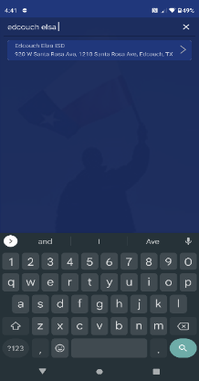
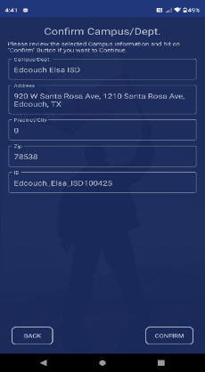
- Tap on “Confirm” on the bottom right of the screen

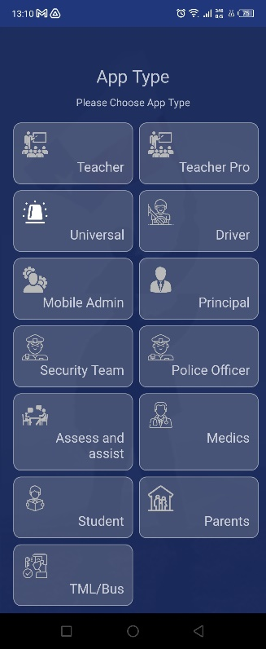
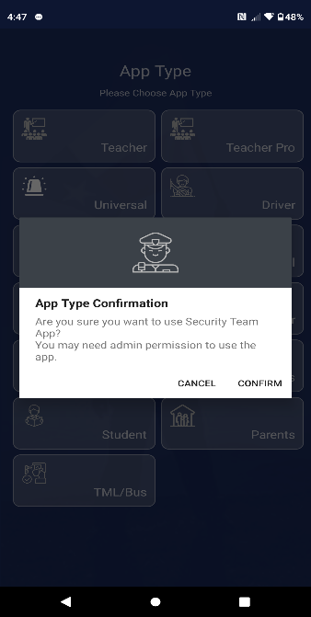

1.6 Selecting Your App Type
- Tap on the “Teachers Pro” button.
- Select “Confirm”
- Accept all permissions

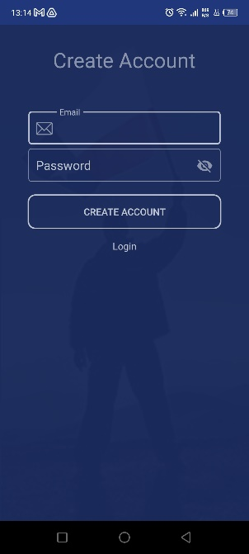

1.7 Create an Account
- Tap on “Create Account”
- Input Email and Password and tap “Create Account” button.

Upon creating your account, you must confirm your email address.
- Once verified, log in.

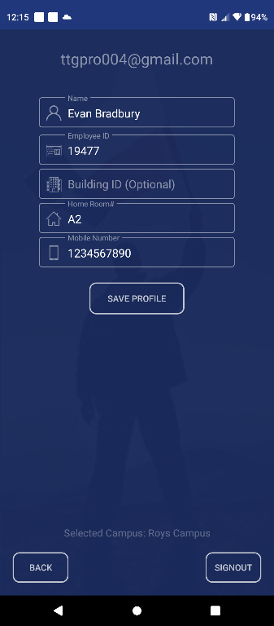
Profile Requirements:
- Full Name
- Employee ID
- Assigned Location
- Mobile Number
- Once completed, tap on “Save Profile”
This app is not functional until the admin has verified and approved your account.

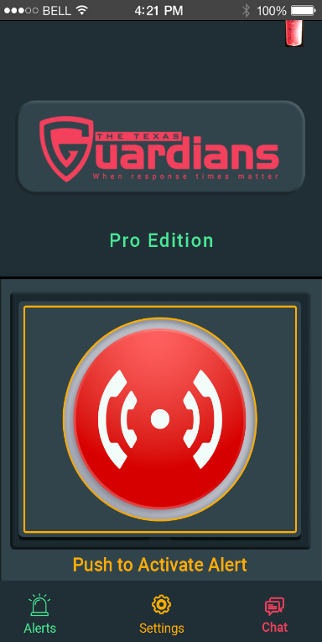
User Guidance

2.1 Primary Emergency Feature
- A single emergency button with a long press feature to prevent accidental activation.

2.2 Hidden Features
- Auto-open 911 upon complete submission of an emergency alert.
- Live location ONLY tracked after submission of an emergency report
- Automatically enables the device “DO NOT DISTURB” feature after submitting a report.
- The emergency button will be under a five (5) minute lockdown period following the initial report submission.
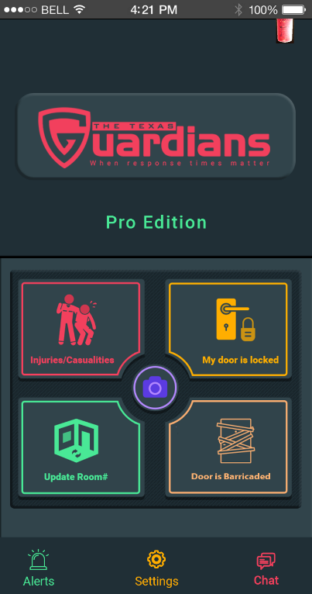

2.3 Additional Information
Submit additional information such as:
- injuries/casualties
- my door is locked
- updated the room number
- door is barricaded
- optional photograph.

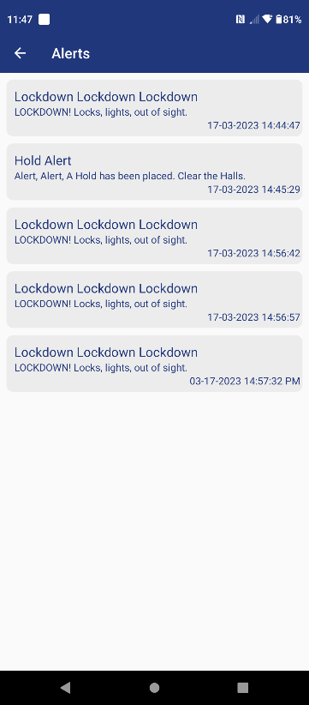
2.4 Alerts Page
- View all mass notification alerts.

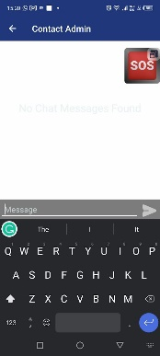

2.5 Chat with Admin
- 1-on-1 Private Message.

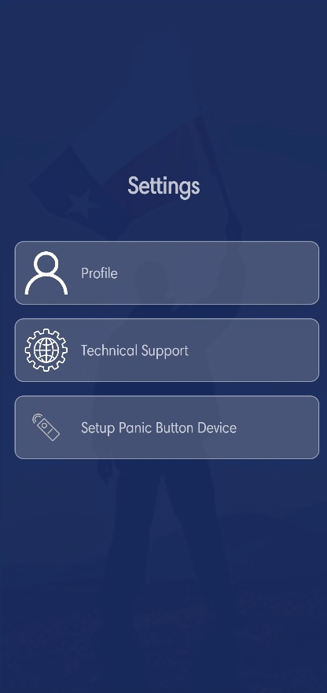
2.6 Settings Page
The Features on the Settings Page are as follows:

- Update your profile information
  - Full Name
  - Employee ID
  - Assigned Location
  - Mobile Number
- Technical Support
  - Online Customer support 24/7.
- Setup Panic Button Device
  - Bluetooth & WIFI setup for the TTG Panic Device.

