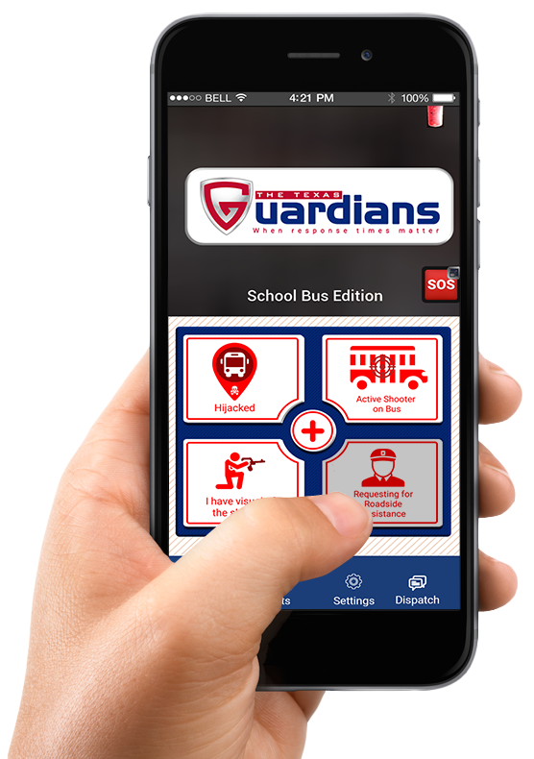
School Safety Mobile App
For Transportation / Bus Drivers
App Information
User Manual 2023
Table of Contents
1. Getting Started 2
1.1 Supported Platforms 2
1.2 Downloading the App 2
1.3 App Permissions 3
1.4 Terms & Conditions 3
1.5 Connecting Campus 3
1.6 Selecting Your App Type 4
1.7 Create an Account 5
2. User Guidance 6
2.1 Primary Emergency Features 6
2.2 Hidden Features 6
2.3 Non-Emergency Features 7
2.4 Alerts Page 7
2.5 Settings page 8
2.6 Chat with Admin 8

Getting Started
The Transportation edition requires an account, prompting you to create one using an email and password. The email must be owned by you (DO NOT SHARE).
Criteria:
    - 6 – 9 characters in length
    - Avoid using first and last name
    - Must include a special character
You are responsible for your account. DO NOT SHARE your account details.

Supported Platforms
Platforms:
- Android Version 10.0+
- iPhone, iOS Version 13+

Downloading the App
Available on App Store and Play Store.
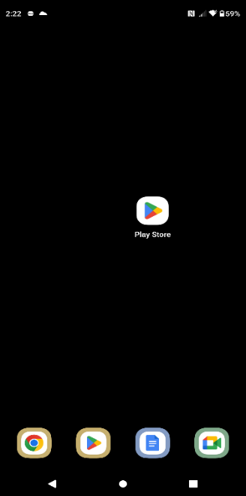
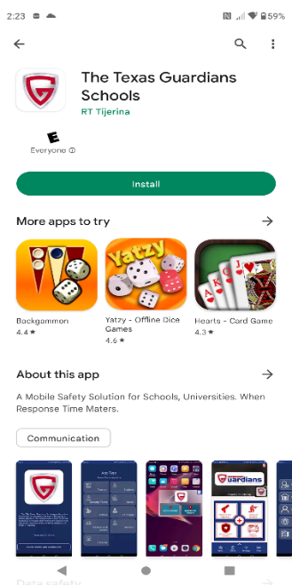
Certain features may be unavailable depending on your device.
Android Play store Download

  - Open Play Store.
  - Search “The Texas Guardians

Schools”
  - Install application.
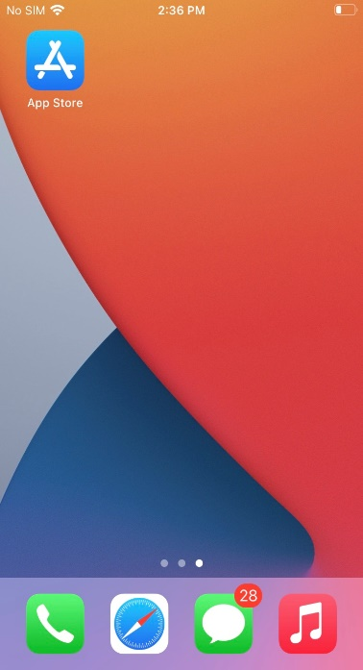
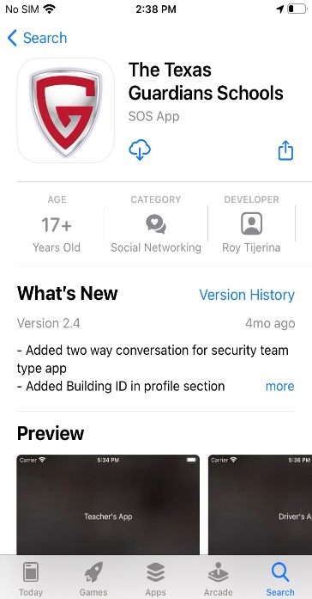

iOS Play store Download
- Open App Store
- Search “The Texas Guardians Schools”
- Install Application

App Permissions
You may be asked to accept permissions during download depending on your device. All permissions must be allowed in order for the application to function properly.

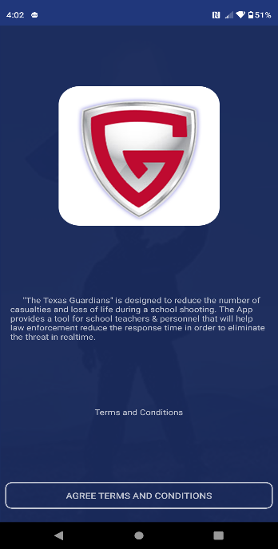
Terms & Conditions
- Read terms & conditions (Strongly Suggested).
- Tap “AGREE TERMS & CONDITIONS” button below.

Connecting Campus
- Tap on “Tap Start Searching”
- Enter your Campus Name
- Select your Campus Name from the list
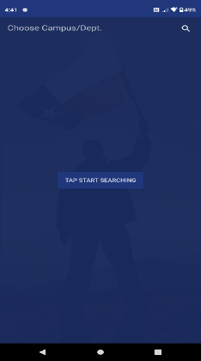
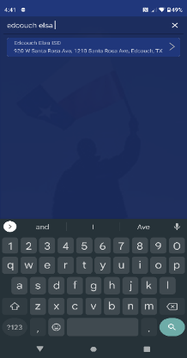
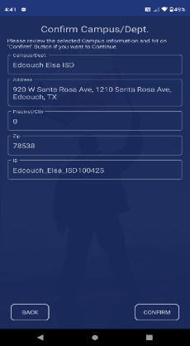
- Tap on “Confirm” on the bottom right of the screen

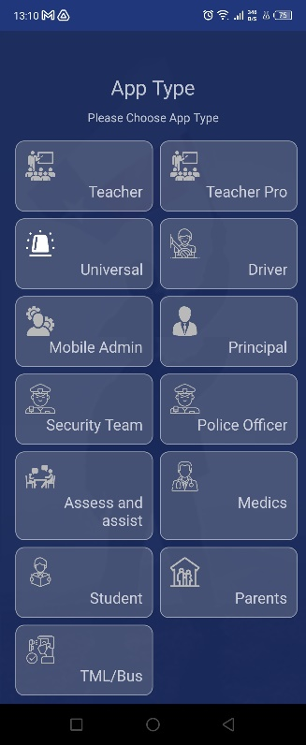
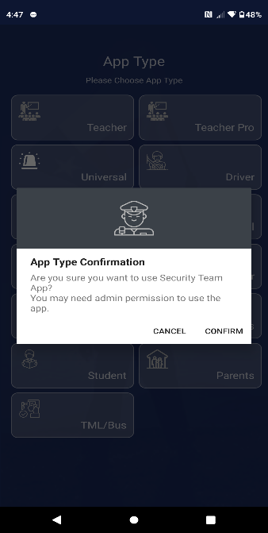

Selecting Your App Type
- Tap on the “Driver” button.
- Select “Confirm”
- Accept all permissions

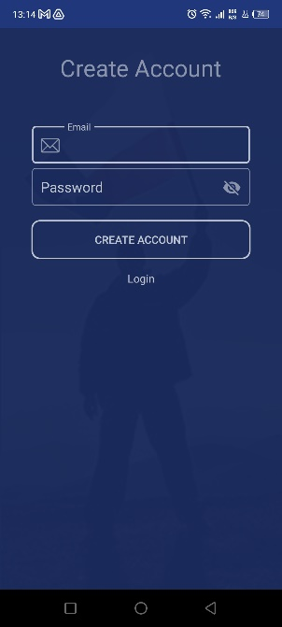

Create an Account
- Tap on “Create Account”
- Input Email and Password and tap “Create Account” button.

Upon creating your account, you must confirm your email address.
- Once verified, log in.

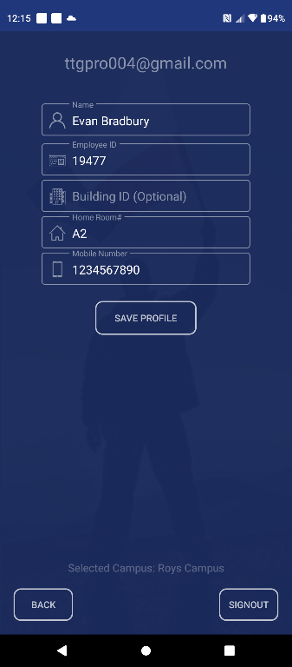
Profile Requirements:
- Full Name
- Employee ID
- Assigned Location
- Mobile Number
- Once completed, tap on “Save Profile”
This app is not functional until the admin has verified and approved your account.

User Guidance

Primary Emergency Features
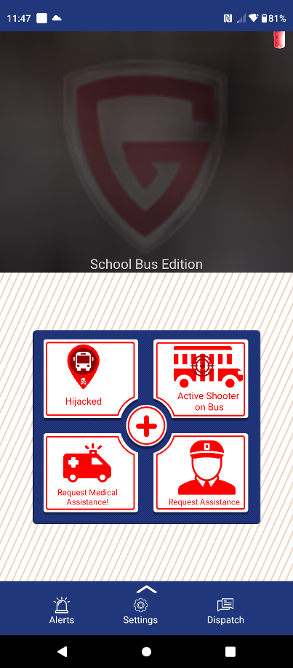
5 Primary Emergency Buttons
- Hijacked
  - Hijacker in control of the vehicle.
- Active Shooter on Bus
  - Active Shooter in Bus.
- Request Medical Assistance
  - Medical Injury
- Medics Help
  - Request Medics
  - Report Injured Persons
- Request Assistance
  - Roadside Assistance.

Hidden Features
- The app will prompt you to enter your device’s pin or pattern when a report is selected.
- Upload an optional image alongside the report. You are NOT required to upload an image.
- Auto-dial 911 upon complete submission of an emergency alert.
- Live location ONLY tracked after submission of an emergency report.
- Manually disable live tracking from the home screen.
- Automatically enables the device “DO NOT DISTURB” feature after submitting a report.

Non-Emergency Features
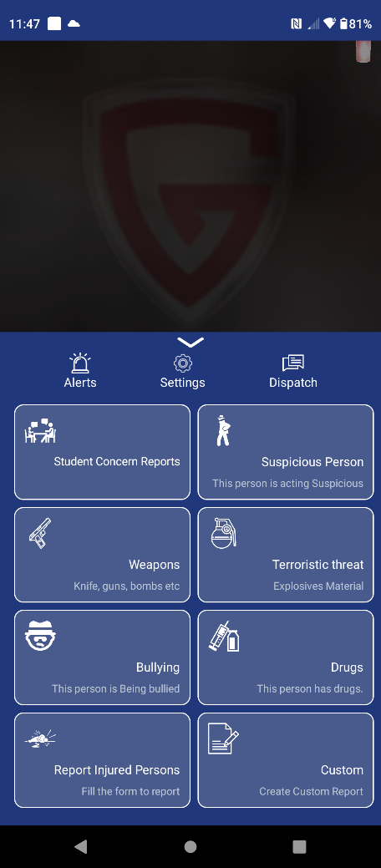
8 Non-Emergency Buttons:
- Student Concerns Reports
  - Mental or physical health concerns.
- Suspicious Person
  - Abnormal Person
- Weapons
  - Non-Firearms.
- Terroristic Threat
  - Comment of a terroristic nature.
- Bullying
  - Bullied Student.
- Drugs
  - Drugs found within the campus.
- Report Injured Persons
  - Non-life-threatening medical injury.
- Custom Report
  - Submit a custom report.
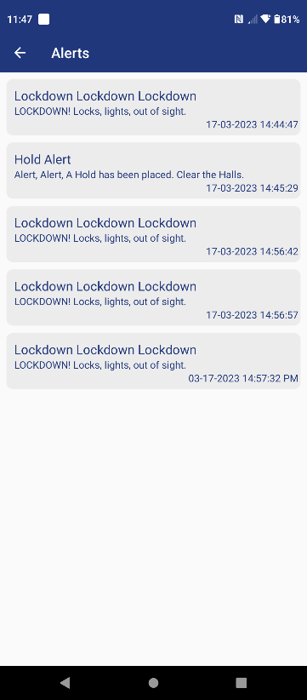
  - Alerts Page
- View all mass notification alerts.

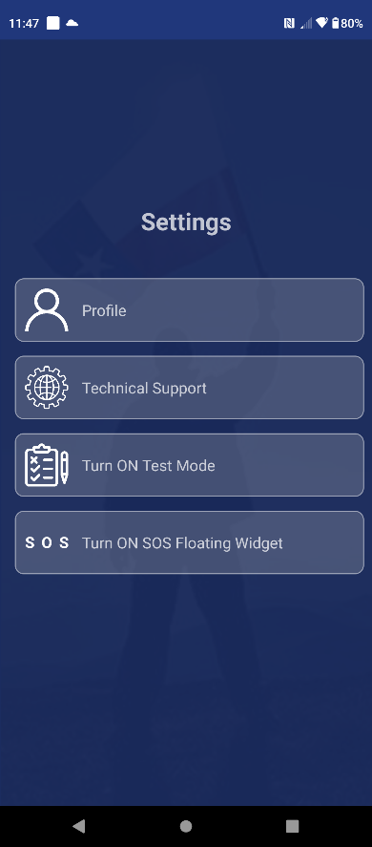
Settings page
The Features on the Settings Page are as follows:

- Update your profile information
  - Full Name
  - Employee ID
  - Assigned Location
  - Mobile Number

- Technical Support
  - Online Customer support 24/7.

- Test mode
  - Verify App Functionality

- SOS Floating Widget
  - “Active Shooter on Bus” & “Hijacked” Reports.
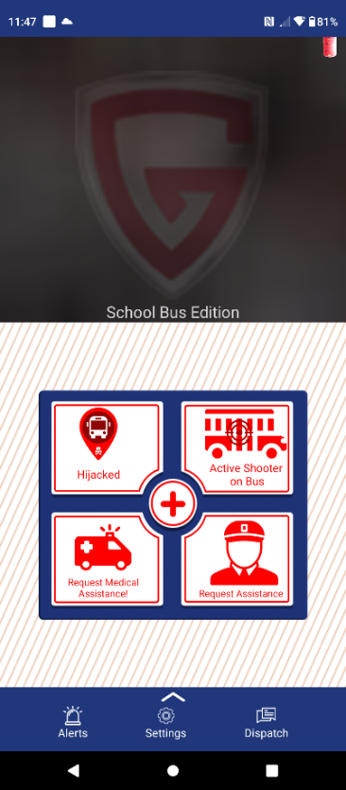

Chat with Admin
- 1-on-1 Private Message.

