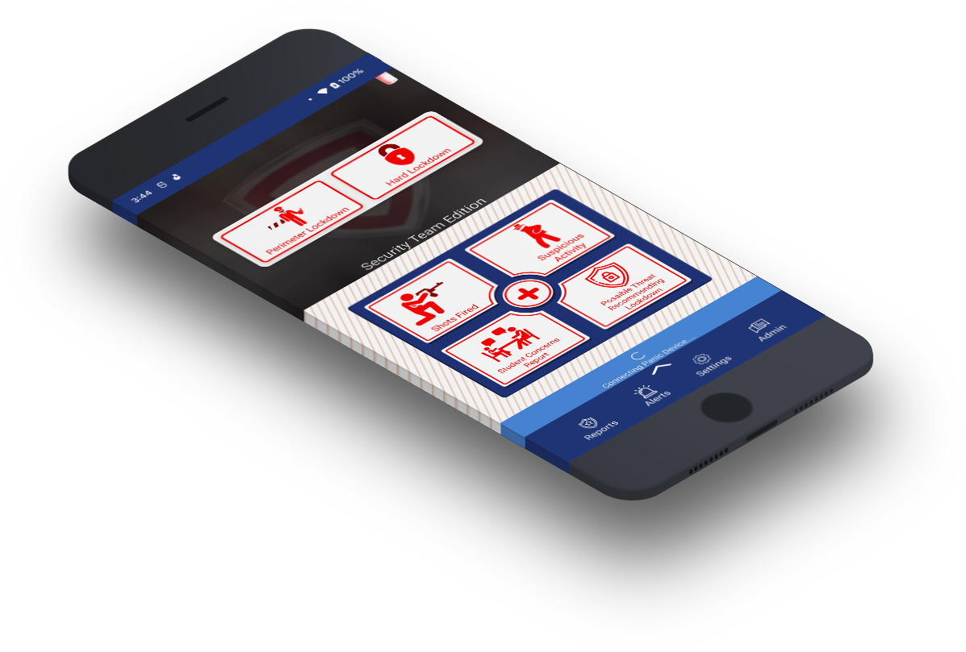
User Manual 2023
School Safety Mobile App
For Security

Table of Contents
1. Get Started 2
1.1 Supported Platforms 2
1.2 Downloading the App 2
1.3 App Permissions 3
1.4 Terms & Conditions 3
1.5 Connecting Campus 4
1.6 Selecting Your App Type 4
1.7 Create an Account 5
2. User Guidance 6
2.1 Primary Emergency Features 6
2.2 Hidden Features 6
2.3 Non-Emergency Features 7
2.4 Reports Page 8
2.5 Alerts Page 8
2.6 Settings Page 9
2.7 Chat with Admin 9

Get Started
Security Edition requires an account, prompting you to create one using an email and password. The email must be owned by you (DO NOT SHARE).
Criteria:
    - 6 – 9 characters
    - Avoid using first and last name
    - Must include a special character
You are responsible for your account. DO NOT SHARE your account details.

1.1 Supported Platforms
Platforms:
- Android Version 10.0+
- iPhone, iOS Version 13+

1.2 Downloading the App
Available on the App Store and Play Store.
Certain features may be unavailable depending on your device.
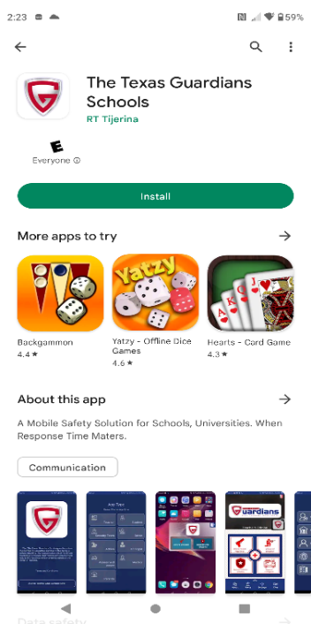
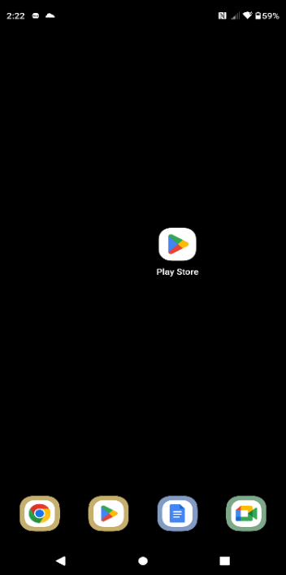
Android Play store Download

  - Open Play store.
  - Search “The Texas Guardians
Schools”.
  - Install application.

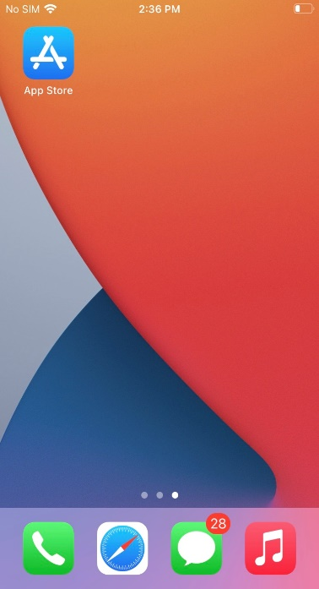
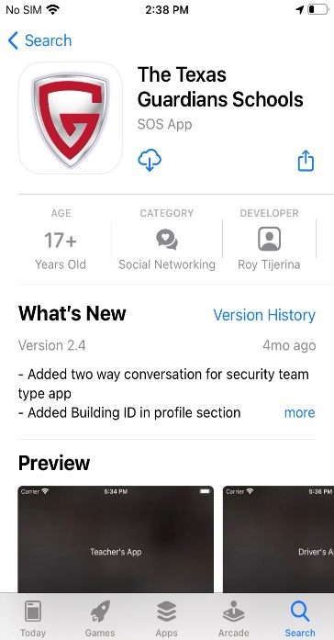

iOS App Store Download
- Open App Store.
- Search “The Texas Guardians Schools”.
- Install application.

1.3 App Permissions
You may be asked to accept permissions during download depending on your device. All permissions must be allowed in order for the application to function properly.

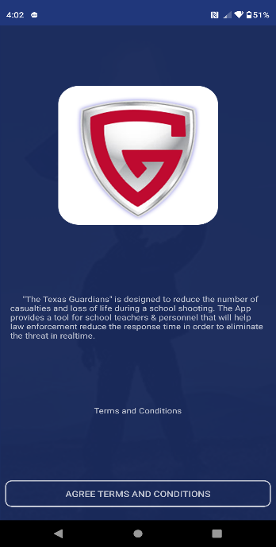
1.4 Terms & Conditions
- Read terms & conditions (Strongly Suggested).
- Tap “AGREE TERMS & CONDITIONS” button below.

1.5 Connecting Campus
- Tap Start Searching button.
- Input your Campus Name.
- Select your Campus.
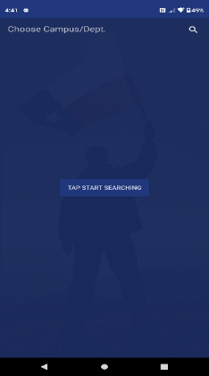
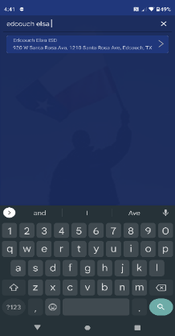
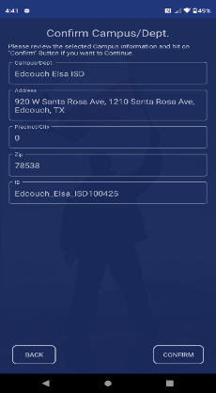
- Hit confirm on the bottom right of screen.

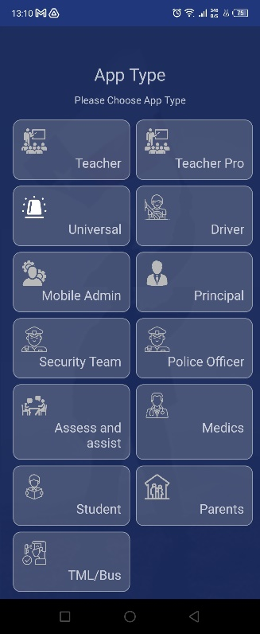
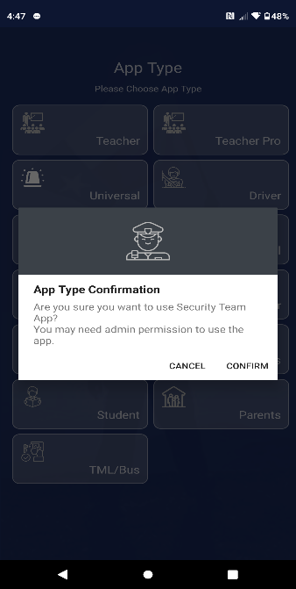

1.6 Selecting Your App Type
- Tap on “Security Team” button.
- Select “Confirm”.
- Accept all permissions

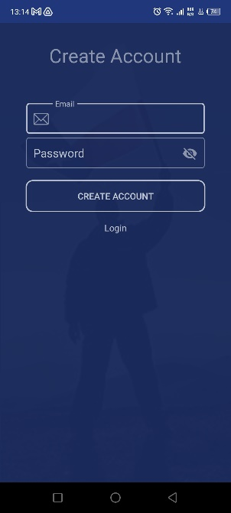

1.7 Create an Account
- Tap on “Create Account”
- Input Email and Password and tap “Create Account” button.

Upon creating your account, you must confirm your email address.
- Once verified, log in.

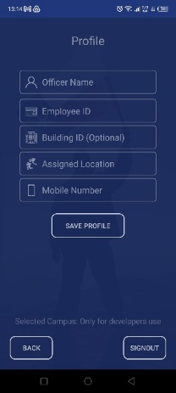
Profile Requirements:
- Full Name
- Employee ID
- Assigned Location
- Device Cell Number
- Once completed, tap on “Save Profile”
This app is not functional until the admin has verified and approved your account.

2. User Guidance
To hear audio alerts from the campus admin or security requests, your phone’s media audio must be unmuted.

2.1 Primary Emergency Features
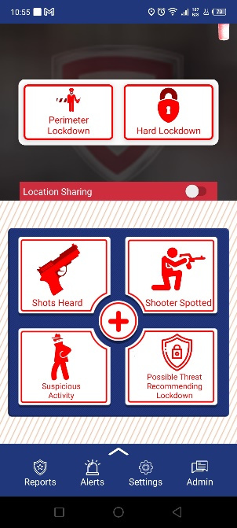
7 primary emergency buttons:
- Perimeter Lockdown
  - Situation outside of campus building(s).
- Hard Lockdown
  - Active Shooter Situation.
- Shots heard
  - Gunshot Detected.
- Shooter Spotted
  - Visual of an Active Shooter.
- Medical Assistance
  - Medical Injury.
- Suspicious Activity
  - Abnormal Behavior.
- Possible Threat Recommending Lockdown
  - Potential threat, not confirmed.

2.2 Hidden Features
- The app will prompt you to enter your device’s pin or pattern when a report is selected.
- Automatically enables the device “DO NOT DISTURB” feature after submitting a report.
- Upload an optional image alongside the report. You are NOT required to upload an image.
- Auto-dial 911 upon complete submission of an emergency alert.
- Live location ONLY tracked after submitting the emergency alert.
- Manually disable the live tracking from the home screen.
- Automatically send’s an SMS message to the emergency contact(s) after submission of an active shooter report.
- Reports submitted are forwarded to all security members for immediate backup.

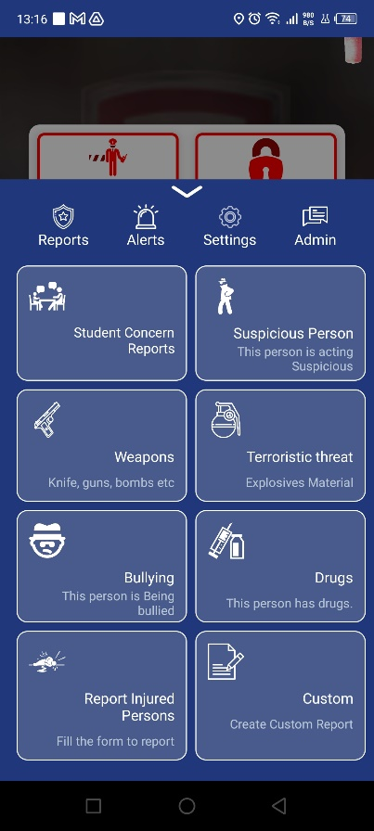
2.3 Non-Emergency Features
8 non-emergency buttons:
- Student Concerns Reports
  - Mental or physical health concerns.
- Suspicious Person
  - Abnormal Person.
- Weapons
  - Non-firearms.
- Terroristic Threat
  - Comment of a terroristic nature.
- Bullying
  - Bullied Student.
- Drugs
  - Drugs found within the campus.
- Report Injured Persons
  - Non-life-threatening medical injury.
- Custom Report
  - Submit a custom report.

2.4 Reports Page
“Requesting for Security” Reports

- Detailed report with user profile information.
- Location marked with a red ping on the map.
- Terrain options for the map.
- Contact the user through SMS or Phone Call.
- Share the report through SMS or Email.
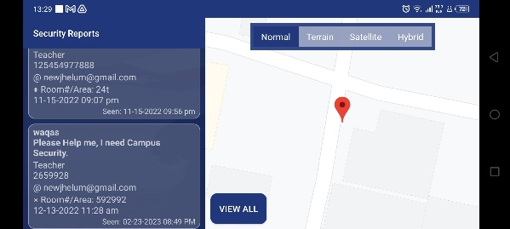

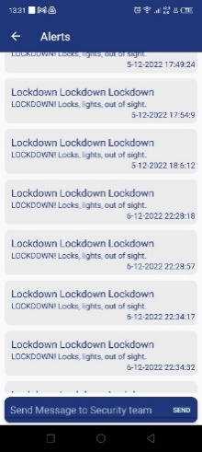

2.5 Alerts Page
View all Alerts

- View all mass notification alerts received.
- View emergency reports received from security members.
- Mass communicate with all security members.

2.6 Settings Page
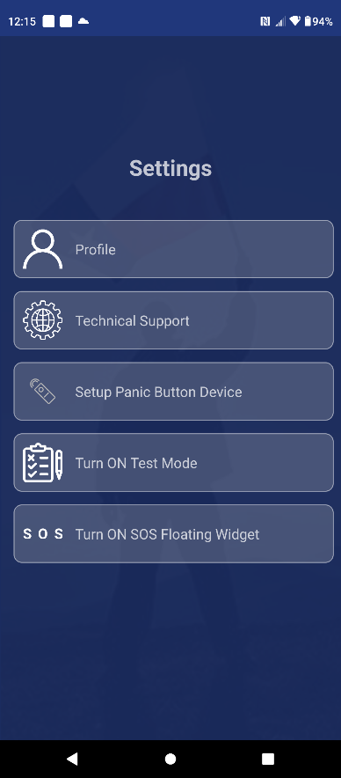
The Features on the Settings Page are as follows:

- Update your profile information
  - Full Name
  - Employee ID
  - Assigned Location
  - Mobile Number
- Technical Support
  - Online Customer support 24/7.
- Setup Panic Button Device
  - Bluetooth & WIFI setup for the TTG Panic Device.

- Test mode
  - Verify App Functionality.
- SOS Floating Widget
  - “Possible Threat! Recommending Lockdown” report.
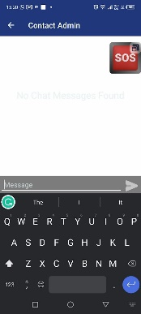
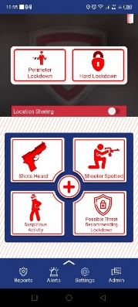

2.7 Chat with Admin
- 1-on-1 private message

